**CHEMISTRY**

**UNIT 1**

**2017**

***Name: ________________________________________________***

**Structure of this paper**

|  |  |  |  |  |  |
| --- | --- | --- | --- | --- | --- |
| Section | Number of questions available | Number of questions to be answered | Suggested working time  (minutes) | Marks available |  |
| Section One:  Multiple-choice | 17 | 17 | 34 | /34 |  |
| Section Two:  Short answer | 6 | 6 | 40 | /36 |  |
| Section Three:  Extended answer | 5 | 5 | 50 | /55 |  |
|  |  |  |  | /125 | /100 |

1. An 56Fe2+ ion contains:
   1. 56 electrons, 56 protons and 26 neutrons.
   2. 26 electrons, 26 protons and 30 neutrons.
   3. 24 electrons, 26 protons and 30 neutrons.
   4. 24 electrons, 30 protons and 26 neutrons.
2. Substance X is a solid that melts at 1520 oC. The substance X conducts electricity in both the solid and liquid states.

Which of the following is most likely to be the structure/property of X?

* 1. Metallic
  2. Ionic
  3. Covalent molecular
  4. Group 17 element

1. The following three-dimensional structure can be used to explain which one of the following species?



* 1. MgO
  2. Diamond
  3. Cu(NO3)2
  4. Na

1. Which of the following elements has only three valence electrons?
   1. Lithium
   2. Boron
   3. Nitrogen
   4. Neon
2. Which of the following pairs of compound names and formulae are correct?
3. Methane CH4
4. Hydrogen peroxide H2O2
5. Sulfuric acid HCℓ
6. Zinc hydroxide Zn(OH)2
   1. I and II only.
   2. II, III and IV only.
   3. I, II and IV only.
   4. I, II, III and IV.
7. Metals are able to conduct electricity because:
   1. The positive metal ions pass charges to each other.
   2. All electrons and the positive metal ions flow around freely.
   3. The valence electrons flow around the metal ions.
   4. All ions are freely moving.

1. Which of the following elements has the highest electronegativity?
   1. O
   2. Li
   3. K
   4. S
2. The decrease in atomic radii across a period in the periodic table is due to the increase in the number of:
   1. neutrons
   2. electrons
   3. protons
   4. shells
3. Element X is likely to form X2+ ion in chemical reactions. This element forms its only chloride by heating X with chlorine gas.

What is the equation for the formation of the chloride of X?

* 1. 2X + Cℓ2 🡪 2XCℓ
  2. X + Cℓ2 🡪 XCℓ2
  3. X + 2Cℓ2 🡪 XCℓ4
  4. X + 3Cℓ2 🡪 XCℓ6

1. Select the most appropriate explanation for why an ionic substance can conduct electricity in aqueous solution but not in the solid state.
   1. In the solid state, the positive and negative ions are fixed within a 3D crystallised lattice that requires a large amount of energy to overcome.
   2. In the solid state, the positive ions and delocalised electrons are in a fixed 3D lattice and cannot move.
   3. In the aqueous solution, the delocalised electrons are no longer in a fixed 3D lattice and are free to move and conduct electricity.
   4. In the aqueous solution, the positive and negative ions are no longer in a fixed 3D lattice and are free to move and conduct electricity.
2. In the technique of mass spectrometry, an element goes through which of the following orders of procedure?
   1. Acceleration, deflection, detection, ionisation.
   2. Acceleration, ionisation, deflection, detection.
   3. Ionisation, deflection, acceleration, detection.
   4. Ionisation, acceleration, deflection, detection.
3. A flame test can be used to distinguish between:
   1. Sodium chloride and sodium carbonate.
   2. Strontium chloride and copper (II) chloride.
   3. Alcohol and ether.
   4. Any two metals.
4. The characteristic line emission spectrum of an element is produced when:
   1. electrons are emitted by an atom.
   2. electrons jump to higher energy levels.
   3. electrons drop back to lower energy levels.
   4. the nucleus absorbs energy from the surrounding.
5. When 3.00 moles of zinc metal reacts with excess hydrochloric acid (HCℓ), how many moles of hydrogen gas is expected to be produced?
   1. 1.50 moles
   2. 2.00 moles
   3. 3.00 moles
   4. 4.50 moles
6. The percentage composition (percentage by mass) of aluminum in aluminum (III) hydroxide is:
   1. 61%
   2. 44%
   3. 35%
   4. 12%
7. For the following **unbalanced** chemical equation:

__ Fe + __ Cℓ2 🡪 __ FeCℓ3

What coefficients would balance the equation?

* 1. 3, 2, 2
  2. 1, 1, 1
  3. 4, 2, 2
  4. 2, 3, 2

1. The formula of hydrated sodium sulfate is Na2SO4∙10H2O. The total number of atoms in one formula unit of this compound is:
   1. 7
   2. 17
   3. 27
   4. 37

**End of Section One**

**Question 21 (6 marks)**

Draw dot diagrams (Lewis structures) for the following. Show all valence shell electron pairs as either : or —

|  |  |  |  |  |  |
| --- | --- | --- | --- | --- | --- |
| For example, water |  | or |  | or |  |

|  |  |
| --- | --- |
| K+ | (1 mark) |
| NCℓ3 | (2 marks) |
| CuCO3 | 1. marks) |

**Question 22 (8 marks)**

Complete the following by giving the name or formula for the following:



|  |  |
| --- | --- |
| **Formula** | **Name** |
| Cu2O |  |
| CCℓ4 |  |
| Mg3(PO4)2 |  |
|  | Aluminium carbonate |
|  | Dinitrogen trioxide |
|  | Calcium Sulfite |
|  | Iron (III) hydrogenphosphate |
|  | Ammonium ion |

**Question 23 (4 marks)**

Observe the table below:

|  |  |  |  |
| --- | --- | --- | --- |
| **Species** | **Protons** | **Neutrons** | **Electrons** |
| A | 6 | 6 | 6 |
| B | 6 | 8 | 6 |
| C | 6 | 7 | 10 |
| D | 11 | 12 | 10 |
| E | 12 | 12 | 10 |
| F | 8 | 8 | 10 |

Using the table above by writing correct letters into the appropriate boxes below.

|  |  |  |  |  |
| --- | --- | --- | --- | --- |
| **Isotopes** |  |  | **Neutral atoms** |  |
| **Anions** |  |  | **Cations** |  |

**Question 26 (7 marks)**

Write balanced **FULL** equations for the following reactions described below. Include the states of matter for all the species. For example, solid copper (II) sulfate as CuSO4 (s).

* 1. Carbon dioxide gas is bubbled into limewater (Ca(OH)2) to produce calcium carbonate precipitate. (2 marks)

__________________________________________________________________________

* 1. Silver nitrate solution is mixed with iron (II) chloride solution to produce solid silver chloride and iron (II) nitrate solution. (2 marks)

__________________________________________________________________________

* 1. Direct heating of solid bicarbonate of soda (sodium hydrogencarbonate). (2 marks)

__________________________________________________________________________

States of matter for all species (1mark)

1. **(4 marks)**

Carbon dioxide is a colourless gas which occupies 0.04% of our atmosphere. The melting point and the boiling point of carbon dioxide are – 56.6 oC and – 78.5 oC respectively.

Explain why carbon dioxide has a very low melting and boiling point.

______________________________________________________________________________

______________________________________________________________________________

______________________________________________________________________________

______________________________________________________________________________

______________________________________________________________________________

______________________________________________________________________________

1. **(7 marks)**

The average human requires 120 grams of glucose (C6H12O6) per day.

* 1. Calculate the percentage by mass of carbon in each glucose molecule. (3 marks)

__________________________________________________________________________

__________________________________________________________________________

__________________________________________________________________________

__________________________________________________________________________

* 1. How many grams of CO2 (in the photosynthesis reaction shown below) are required to produce 120.0g of glucose?

6CO2 + 6H2O 🡪 C6H12O6 + 6 O2

(4 marks)

__________________________________________________________________________

__________________________________________________________________________

__________________________________________________________________________

__________________________________________________________________________

__________________________________________________________________________

**End of Section**

**Section Three: Extended answer 40% (60 marks)**

This section contains **five (5)** questions. You must answer **all** questions. Write your answers in the spaces provided below.

Where questions require an explanation and/or description, marks are awarded for the relevant chemical content and also for coherence and clarity of expression. Lists or dot points are unlikely to gain full marks.

Final answers to calculations should be expressed to the appropriate number of significant figures.

Spare pages are included at the end of this booklet. They can be used for planning your responses and/or as additional space if required to continue an answer.

* Planning: If you use the spare pages for planning, indicate this clearly at the top of the page.
* Continuing an answer: If you need to use the space to continue an answer, indicate in the original answer space where the answer is continued, i.e. give the page number. Fill in the number of the question(s) that you are continuing to answer at the top of the page.

Suggested working time: 60 minutes.

1. **(13 marks)**

The following simplified diagram shows the path of a 20Ne+ ion through a mass spectrometer.

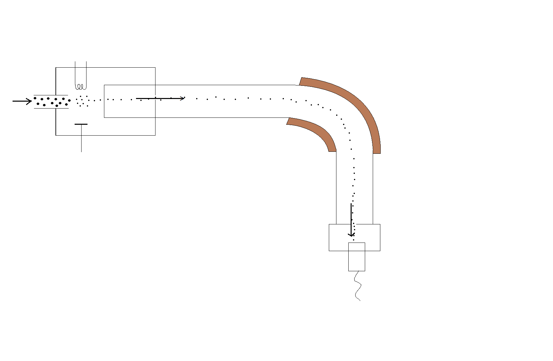

A

* + 1. What is found at part A in this mass spectrometer? (1 mark)

_____________________________________________________________________

* + 1. Why is part A required in this mass spectrometer? (1 mark)

_____________________________________________________________________

_____________________________________________________________________

**Continue Question 29**



* + 1. On the diagram of the mass spectrometer, sketch the path that would be taken by a 21Ne+ ion introduced if it were injected into the spectrometer at the same time as the 20Ne+ ion shown. (1 mark)
    2. Explain why the paths travelled by the two ions differ. (2 marks)

_____________________________________________________________________

_____________________________________________________________________

_____________________________________________________________________

The relative abundances of all the neon isotopes in a sample is collected using the mass spectrometer. The result is shown below. Note that m/z value is equivalent to the mass number of a neon ion. (For example, m/z = 20 means 20Ne+ isotope.)

* 1. Use the above graph to calculate the relative atomic mass of neon. (2 marks)



__________________________________________________________________________

__________________________________________________________________________

__________________________________________________________________________

__________________________________________________________________________

__________________________________________________________________________



Atomic absorption spectroscopy (AAS) can be used to distinguish different elements such as neon and helium atoms. The diagram below shows the emission spectra of helium and neon.

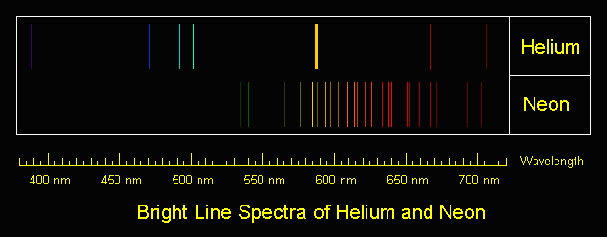

* 1. Explain how these spectra lines are produced. (3 marks)

__________________________________________________________________________

__________________________________________________________________________

__________________________________________________________________________

__________________________________________________________________________

__________________________________________________________________________

__________________________________________________________________________

* 1. The spectra of helium and neon are different. Give an explanation for this.

(3 marks)

__________________________________________________________________________

__________________________________________________________________________

__________________________________________________________________________

__________________________________________________________________________

__________________________________________________________________________

__________________________________________________________________________

1. **(17 marks)**

Nanoparticles are particles between 1 and 100 nanometres in size. In nanotechnology, a particle is defined as a small object that behaves as a whole unit with respect to its transport and properties. Ultrafine particles are the same as nanoparticles and are between 1 and 100 nanometres in size, fine particles are sized between 100 and 2,500 nanometres, and coarse particles cover a range between 2,500 and 10,000 nanometres. Scientific research on nanoparticles is intense as they have many potential applications in medicine, optics, and electronics.

* 1. How do bulk materials differ from nanoparticles mentioned above?

(2 marks)

__________________________________________________________________________

__________________________________________________________________________

__________________________________________________________________________

* 1. Explain the advantages and concerns of the use of nanoparticles in some sunscreens.

(4 marks)

__________________________________________________________________________

__________________________________________________________________________

__________________________________________________________________________

__________________________________________________________________________

__________________________________________________________________________

__________________________________________________________________________

__________________________________________________________________________

__________________________________________________________________________

Carbon nanotubes (CNT’s) are allotropes of carbon with a cylindrical nanostructure. An example of a CNT is shown on the right.

* 1. 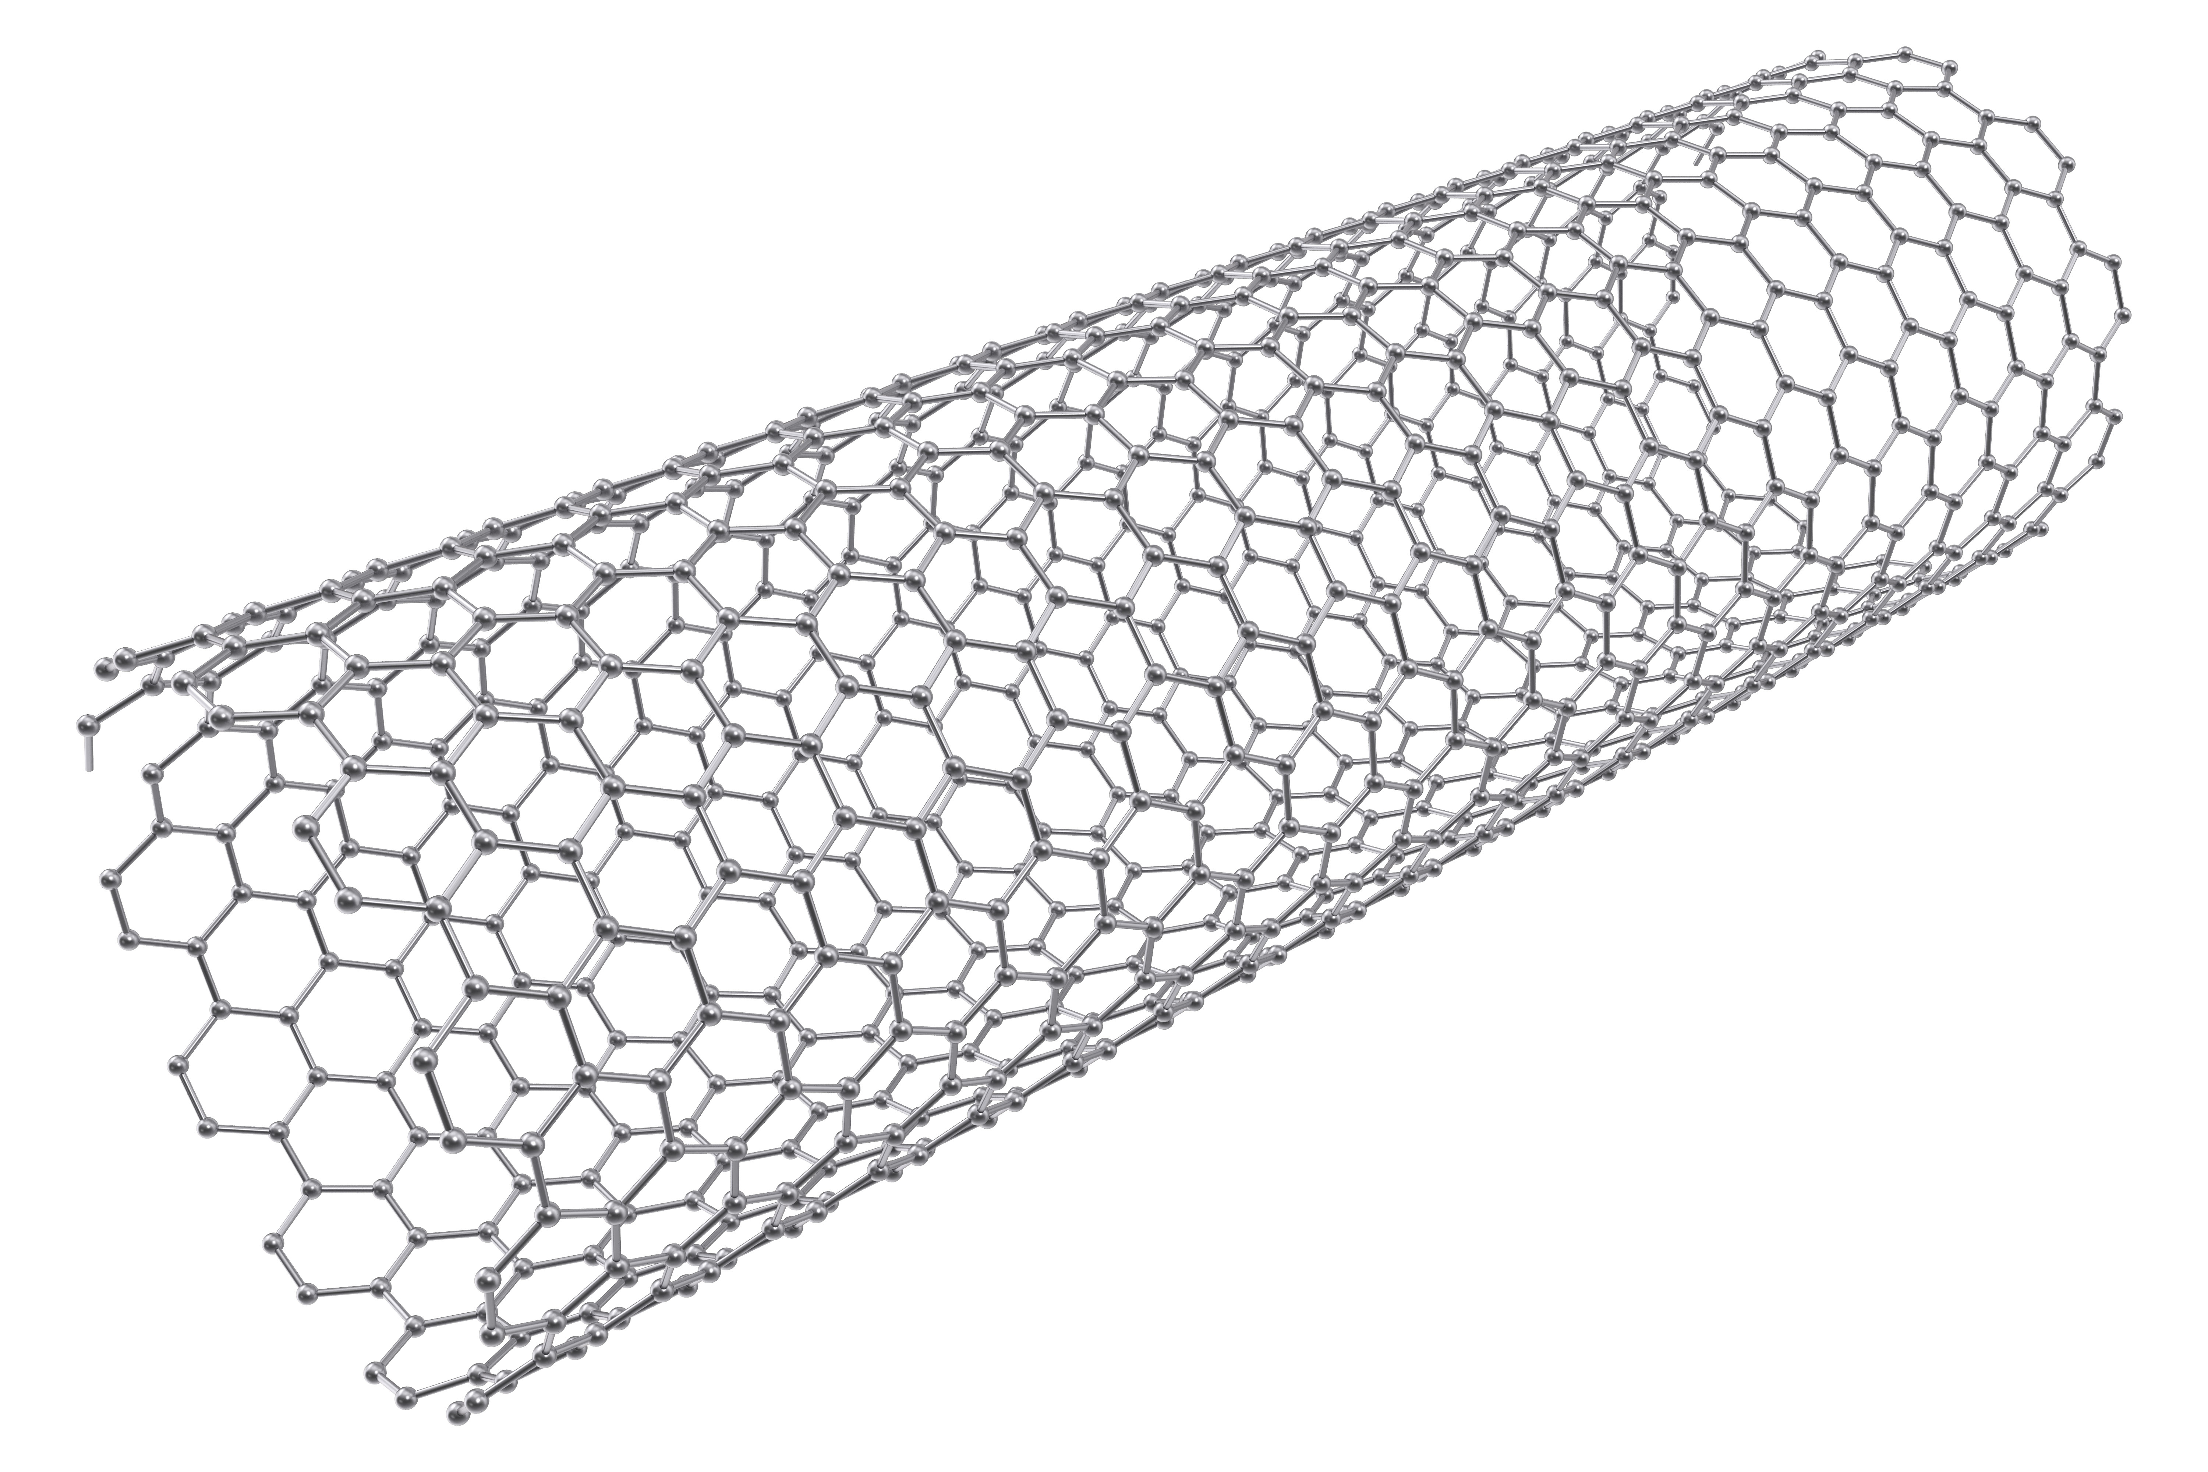List TWO benefits of CNT’s.

(2 marks)

_______________________________________________

_______________________________________________

* 1. Diamond and graphite are also allotropes of carbon. What is an allotrope?

(2 marks)

__________________________________________________________________________

__________________________________________________________________________

__________________________________________________________________________

* 1. With the use of a labelled diagram, describe the chemical bonding and structure of graphite. (7 marks)

__________________________________________________________________________

__________________________________________________________________________

__________________________________________________________________________

__________________________________________________________________________

__________________________________________________________________________

__________________________________________________________________________

__________________________________________________________________________

__________________________________________________________________________

__________________________________________________________________________

|  |
| --- |
| **Diagram** |

1. **(16 marks)**

When magnesium metal reacts with oxygen from the air, a grey-white solid is formed. This chemical reaction can be performed in a crucible in the science lab.

* 1. Write a balanced chemical equation for this reaction. (2 marks)

__________________________________________________________________________

The setup of the combustion reaction is shown below:

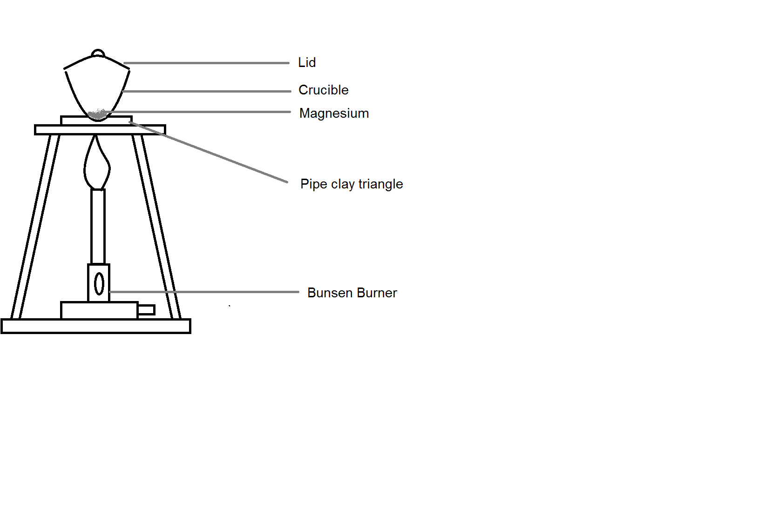

A student, Paul, wants to use this experiment to find the mass of oxygen reacting with the magnesium.

* 1. The teacher of the student, Mrs Philips, suggests that the lid of the crucible need to be open slightly during the combustion. Explain the reason for this. (1 mark)

__________________________________________________________________________

__________________________________________________________________________

__________________________________________________________________________

After the experiment, Paul summarises his result as follows:

Mass of crucible and lid (g) 38.5980 g

Mass of crucible, lid and magnesium (g) 38.7860 g

Mass of crucible, lid and magnesium oxide (g) 38.8873 g

* 1. Use Paul’s results to calculate:

(2 marks)

|  |  |
| --- | --- |
| **Mass of Magnesium (g)** |  |
| **Mass of Magnesium oxide (g)** |  |

* 1. Calculate the number of moles of magnesium at the beginning of the experiment. (2 marks)

__________________________________________________________________________

__________________________________________________________________________

__________________________________________________________________________

__________________________________________________________________________

* 1. Calculate the number of moles of magnesium oxide produced at the conclusion of the experiment. (2 marks)

__________________________________________________________________________

__________________________________________________________________________

__________________________________________________________________________

* 1. Write a balanced equation and using your answer from part (d), calculate the number of moles of magnesium oxide Paul is **expected** to produce in this experiment. Explain why the expected value is different to part (e). (3 marks)

__________________________________________________________________________

__________________________________________________________________________

__________________________________________________________________________

__________________________________________________________________________

* 1. Use the answer from part (d), calculate the theoretical mass of the oxygen gas reacted in this combustion. How does this value compare to the amount which actually reacted? (4 marks)

__________________________________________________________________________

__________________________________________________________________________

__________________________________________________________________________

__________________________________________________________________________

__________________________________________________________________________

__________________________________________________________________________

__________________________________________________________________________

__________________________________________________________________________

1. **(9 marks)**

A fuel is any material that can be made to react with oxygen gas so that it releases energy as heat. Fossil fuels are fuels from natural processes such as anaerobic decomposition of buried dead organisms. One example of a fossil fuel is ethane.

The **unbalanced** chemical equation of the combustion of ethane is shown below:

C2H6 + O2 🡪 CO2 + H2O

* 1. Balance the chemical equation above using whole numbers.

(1 mark)

* 1. Draw dot diagram (Lewis structures) for C2H6. Show all valence shell electron pairs as either : or —. (2 marks)

|  |  |  |  |  |  |
| --- | --- | --- | --- | --- | --- |
| For example, water |  | or |  | or |  |

|  |  |
| --- | --- |
| C2H6 |  |

1.00 tonne of ethane gas is pumped into a combustion chamber to undergo this combustion reaction. Assume that there is no loss of energy in the reaction.

* 1. Calculate the number of moles of ethane reacted. (2 marks)

__________________________________________________________________________

__________________________________________________________________________

__________________________________________________________________________

__________________________________________________________________________

**Continue Question 32**

* 1. Calculate the mass, in tonnes, of oxygen required in this reaction if the ethane is fully reacted. (4 marks)

__________________________________________________________________________

__________________________________________________________________________

__________________________________________________________________________

__________________________________________________________________________

__________________________________________________________________________

__________________________________________________________________________

__________________________________________________________________________